1. After simulating or otherwise verifying your design, create or import a constraints file to the constraints folder in the Sources pane of the Project Manager window.

* Use the ZYNQ7000 FPGA Development Board AX7010 – User Manual to determine the pin assignment.
* PL = Programming Logic accessible to FPGA fabric and ARM
* PS = Processing System only accessible to ARM

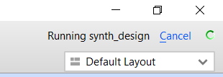2. Click Generate Bitstream in the Project Manager window

* In the Launch Runs pop-up, click OK
* The upper right corner of the Vivado window will show progress

3. Connect the USB cable and power cable to the ALINX board.

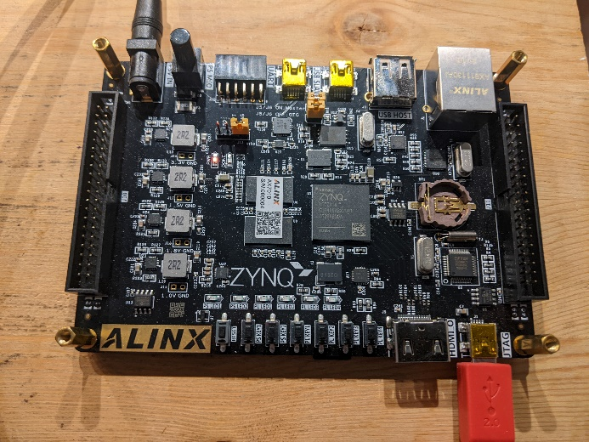

3. Opening the implemented design is a waste of time, just close this window.

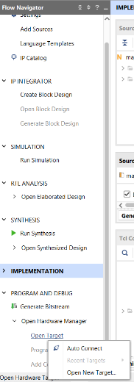

4. Click on Open Target -> Auto Connect.

5. At the top of the screen in a green bar, click Program device

* Click Program in the Program device pop-up

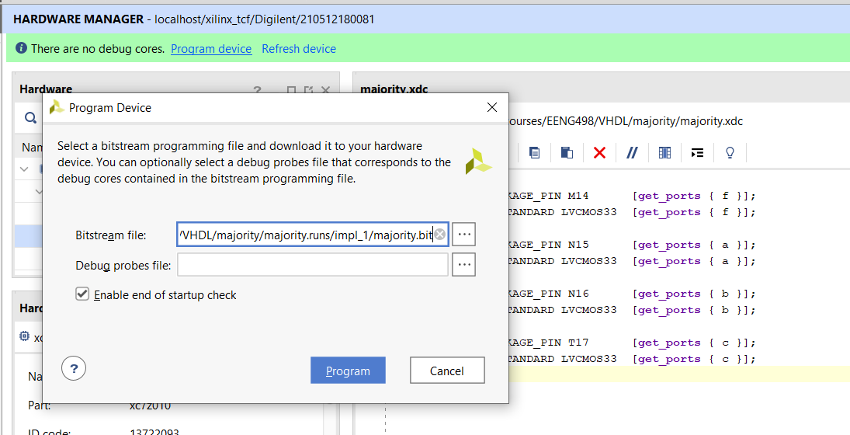

6. Your design is successfully programmed.